ECE R90 Conformity to European Standard Requirements

Date: 31 July 2026

To whom it may concern

This letter is to confirm that the following Brake Pads (and certification numbers) supplied by Juratek Ltd comply with the above requirements.

JCP006 E11 90R-01393/8075
JCP013 E11 90R-01393/8076
JCP1001 E11 90R-01393/7682
JCP1002 E11 90R-01393/7686
JCP1388 E11 90R-01393/8070
JCP1000 E11 90R-01393/7687

Juratek is unable to release such documents because they contain supplier information details but should you have any further concerns regarding this matter, please contact me directly.

Yours Sincerely

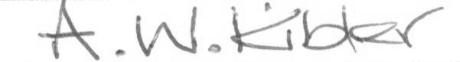

Andrew Kibler
Engineering & Quality Manager
Juratek Ltd
E-mail: quality@juratek.com
Tel: +44 1302 246218
Fax: +44 1302 774936

